1. Assembly of a Voltage Monitor Device and Measurements

Lab Experiment 1+2 in the Bachelor Course Electronics, Signals and Measurement

(Two dates, first day focus on assembly and first measurements, second day on main measurement tasks)

**Content**

1. Learning Target 1

2. Voltage Monitor 2

3. List of components 3

4. Assembly 4

5. Devices and basic information 7

6. Experiments 11

6.1 Connect the board to the power supply and function testing 11

6.2 Voltage and Current Measurement 11

6.3 LED voltage measurement 12

6.4 Measurement of voltage of the Zener Diode ZD1 and the current over ZD1 13

6.5 Voltage measurement when LED1 and LED2 are emitting simultaneously light 13

7. Function 14

# Learning Target

Practical experience in soldering of THT (Through Hole Technology) devices. First encounter with linear and nonlinear electronic devices, e.g. resistors, capacitor, diodes (Z-diode, rectifier diode and light emitting diode) and bipolar transistor and its characteristic curves, voltage and current measurement. Circuit analysis and understanding of the function of the voltage monitor device.

# Voltage Monitor Device

The voltage monitor device is designed to measure the state of charge of a rechargeable battery, i.e. the voltage. When the voltage is in the low range, the red LED lights up, in the middle range the yellow LED and finally in the high voltage range (when the battery reached its defined voltage) the green LED.

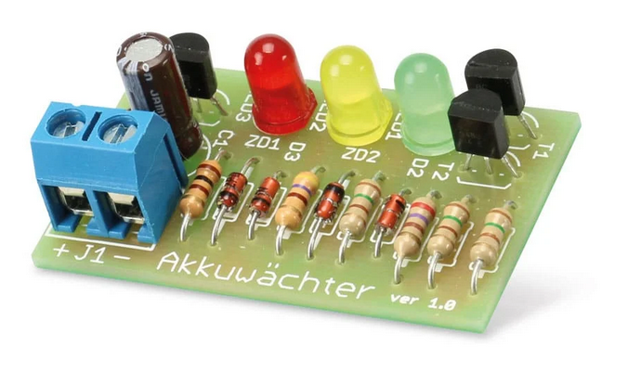

Figure 1 Voltage Monitor for batteries of 12V. Do not connect 230 V voltage under any circumstances. There is a danger to life! We connect it solely to 20V DC voltage.

The mounting diagram of the devices is depicted below.

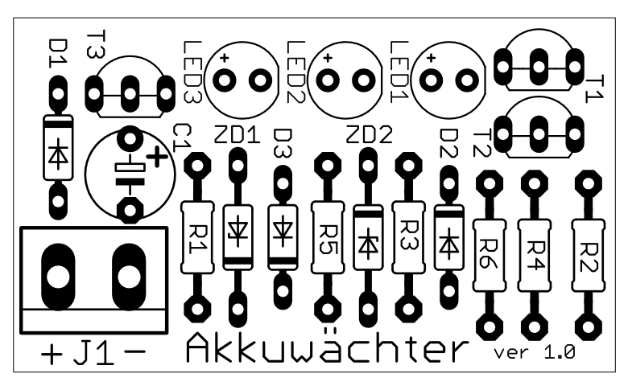

Figure 2 Mounting diagram

The electronic circuit is depicted below.

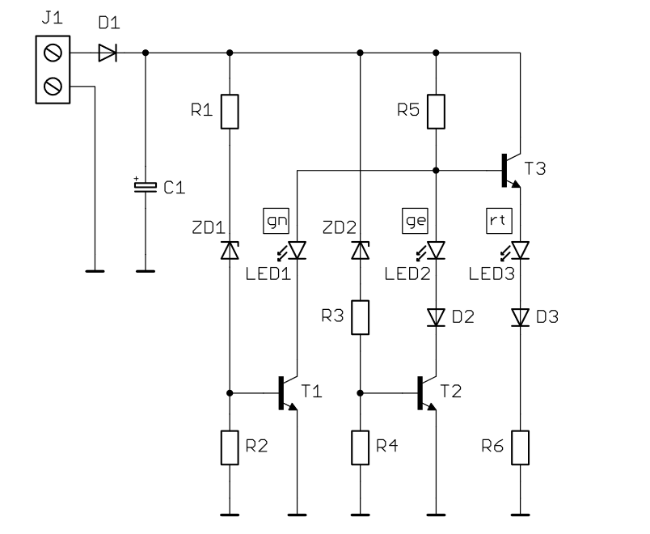

Figure 3 Electric circuit diagram

# List of components

The devices (parts) are listed below.

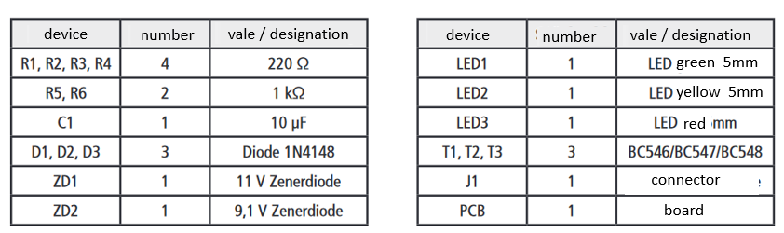

Figure 4 Part list.

# Resistor Measurement and Multi-Meter

Get family with the settings of a multi-meter.

Why are there different position of the multi-meter switch for the measurement of low and high voltages and low and high currents? What is changed when the switch position is changed to measure small or high voltages/small or high currents?

How functions the measurement of a resistor with a multi-meter?

Measure the precise resistance of R1, R2, R5 and R6. We need them later. Below (section six), you find the instruction how to read the colour rings on the resistors.

|  |  |  |  |
| --- | --- | --- | --- |
| R1 | R2 | R5 | R6 |
|  |  |  |  |

# Assembly

**Before you start**

The actual assembly should be carried out on a clean and heat-resistant surface. Plan for construction enough time and proceed with the necessary calm and care to detect assembly errors and avoid all resulting hazards and damage. After checking the part list, you should first start assembling the components that have the lowest package height. As a result, you should follow the order of the instructions to create the simple assembly. Usually, you would push the components on the board. **But to ease the voltage measurement later with the clamps, assemble the components that they are 1-2mm above the top side of the board. Also do not cut the excessive length of the leads later.**

**Board**

The green board is made out of an insulating layer which is metallized on one or both sides with copper. A copper foil has been attached (layer pressing by temperature and pressure) onto the dielectric material (FR4, woven glass soaked with epoxide). The copper layer is structured by galvanic and wet etch processes. On the top side the assembly plan (component indicator) is printed.

**Soldering**

The THT components (THT: Through Hole Technology) are assembled from the top side: The leads are bended and moved through the holes. With the solder iron the metal leads and the pad are heated up. You melt the solder wire so that the liquid solder can wet the pad and the lead.

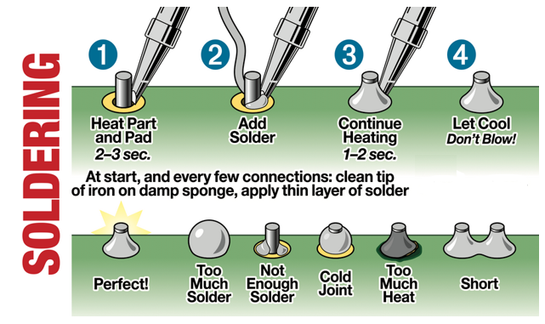

Figure 5 How to solder and how a good solder joint looks like.

**Diodes and Zener-Diodes: Pay attention to polarity**

Start by soldering the diodes first. The type of diodes is printed on their housing. When assembling the diodes, it is advisable to bend their connecting wires at right angles according to the grid dimensions. You push the wire through the holes for the diode. **It is essential to take the polarity of the diode into account (the cathode line on the diode must match the line on the printed circuit board).** After you have put the wires through the holes you bend the wires slightly to the side to prevent the components from slipping through. Now you solder the connection from the bottom. Usually you would shorten the remaining leads, but we want to measure voltages later on with clamps. Therefore you leave the leads uncut. The slightly longer leads will be helpful.

**Resistors**

In order to start the assembly of the resistors, it is first necessary to determine the value of each resistor in order to be able to place it correctly on the circuit board. The color code printed on the resistor can be used to determine the resistance value (see table) or the value of the resistor can be measured using a multi-meter. To read the color code of the resistor make sure the gold-colored tolerance ring is on the right side of the resistor body. The colored rings will then be read from left to right.

|  |  |  |  |  |  |
| --- | --- | --- | --- | --- | --- |
| R1, R2, R3, R4 | 220 Ω | Red | Red | brown | Gold |
| R5, R6 | 1k Ω | Brown | Black | red | Gold |

After determining the resistance value, the connecting wires of the resistor should be bent according to the hole spacing at right angles and plugged into the holes provided on the circuit board (see assembly plan). To prevent the resistors from falling out when the board is turned over, bend the connecting wires slightly outside and solder them to the solder points on the back of the circuit board. (Then, usually, you would cut off the excess wires off – but we don’t do it to ease measurements.)

**Transistors**

Transistors have 3 connections: base B, emitter E and collector C. When soldering the transistors, pay particular attention to the correct orientation of its connections otherwise the component will be damaged or the circuit will not function. The half-circle shape of the transistor must be aligned with the corresponding symbol on the assembly plan. (Usually, you would shorten the leads after soldering the transistors and trim the lead wires to an appropriate length.)

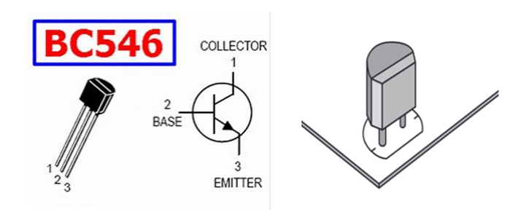

Figure 6 Transistor terminals

**Electrolyte Capacitor:** **Pay attention to the polarity**

The value of the capacitors or electrolytic capacitors is printed on the component. Due to the design of an electrolyte capacitor, it is essential to pay attention to the polarity (for other capacitors this is not the case). Depending on the manufacturer, electrolytic capacitors have different polarity markings. Some manufacturers mark the positive pole with “+”, while others mark the negative pole with “-”. Please make sure that the polarity of the electrolytic capacitor matches the polarity of the printed circuit board. The connection wires of the electrolytic capacitors should be connected just as the previously assembled components, i.e. slightly outwards bended on the underside of the circuit board so that these components don’t fall of when the circuit board is turned over. Solder the connecting wires. Usually, the wire ends of the components should be shortend after the components have been soldered but we don’t do it to be able to better contact the leads in case we need to do measure from the bottom side.

**Terminal Clamp**

The connection terminal (J1) should be positioned according to the assembly plan on the circuit board and its connection pins should be soldered to the underside of the circuit board. Due to the size of the soldering pad, the heating-up time is considerably longer until the solder starts to flow and wets the pad. Only a careful and sufficiently hot soldering promise good contact and long lifetime.

**Light emitting diodes (LED):** **Pay attention to the polarity**

When assembling the light-emitting diodes, you must also pay attention to the polarity. You have an anode (positive pole) and a cathode (negative pole), with the longer connecting wire being the positive pole (anode) and the shorter connecting wire represents the negative pole (cathode). Solder the LED that the almost the full length of the LEDs remains, i.e. they are roughly two centimeter above the top board side.

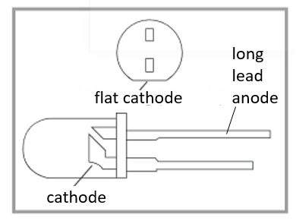

Figure 7 Anode and cothode of a LED

# Devices and basic information

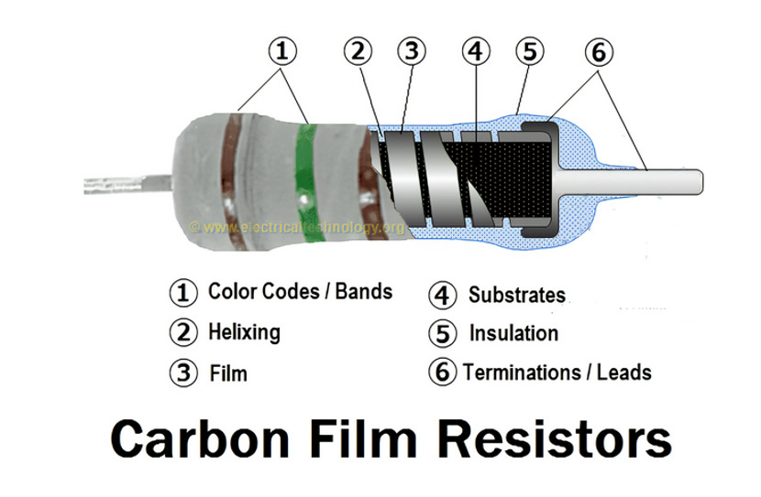**1) Resistor:** On an insulating rod a thin conductive metal or carbon film is deposited. The leads are welded to the substrate and the film. The device is encapsulated by an insulating material like glass or ceramic.

The resistor value and its tolerance is coded by colour rings.

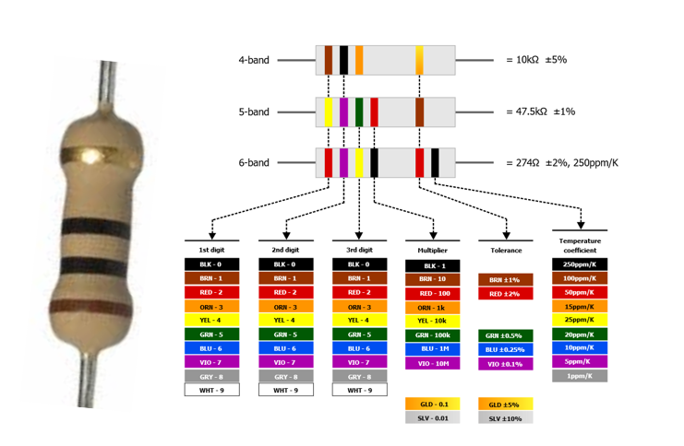

**2) Diode:** A diode is a nonlinear device. The characteristic curve is given below.

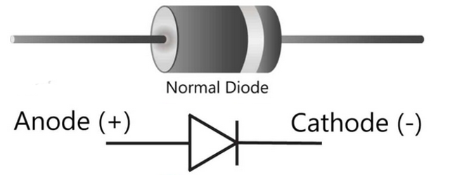

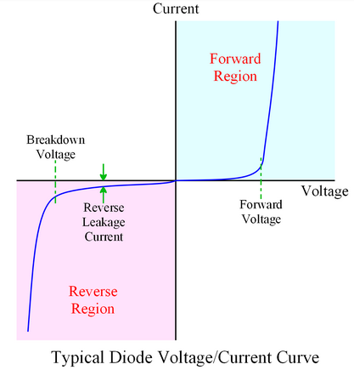

The current in forward direction which flows through the diode in dependence of the forward voltage , which is applied at the LED, is described by the Shockley equation.

called the reverse current, VT is the temperature dependent thermal voltage (26mV at 300K) an n the emission or ideality factor, which depends from the technical realization of the pn-junction and the operation condition. For Vd>>VT you can neglect the “-1” in the bracket because the exponential curve is much larger than 1. This is the case for your data we measure and evaluate later.

The diode conducts current only in one direction (forward direction). However, when applying a large voltage in reverse direction the diode will get conducting again (breakdown voltage due to avalanche or Zener effect).

A simplified characteristic curve (offset voltage diode model) of a diode in forward direction is depicted below: The diode conducts - let current flow - at the voltage Vg.

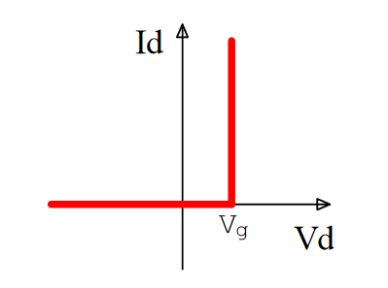

Figure 8 Offset diode model. For silicon diodes Vg is approx. 0.6V (low level signal diodes).

Diodes can be used as rectifier diodes, i.e. to conduct the current only in one direction. In an electric circuit a rectifier diode is used as inverse-polarity protection diode, i.e. it ensures that the voltage is blocked and no current flows when plus and minus supply cabel are connected wrongly.

**3) LED:** An LED is a diode which emits light. Typical semiconductor material for LEDs is GaAs (red LED) and GaN (blue LED).

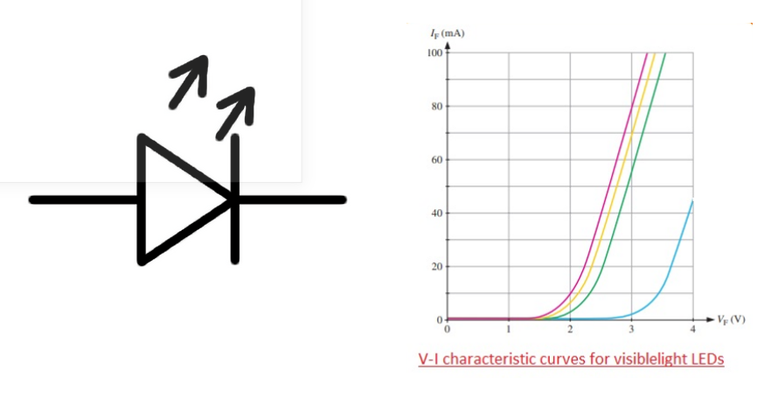

Figure 9 Characteristic curves of LEDs

**4) Z-Diode:** A Z-diode is used in the reverse direction. The breakdown voltage, i.e. the voltage at which the diode gets conductand in the reverse direction by the avalache or the Zehner effect can be adjusted by the pn-junction design, so that at a specified voltage value in reverse direction the z-diodes gets conductand.

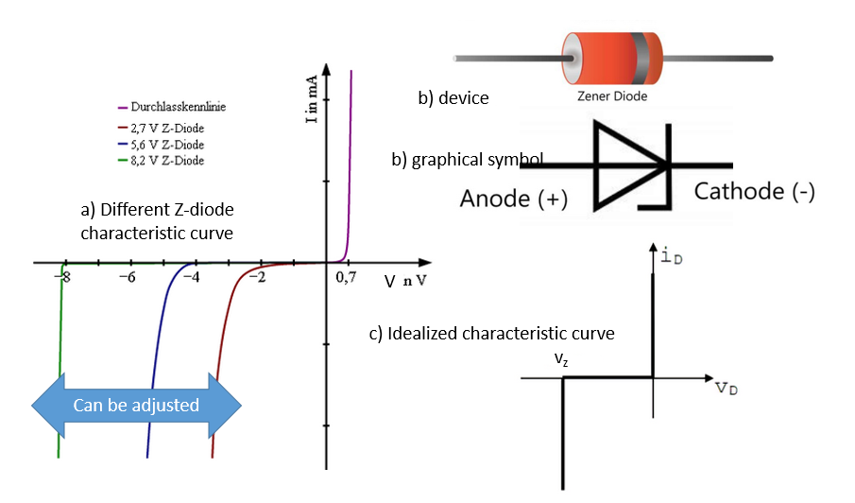

Figure 10 Z-diode. Note, that in forward direction for the idealized characteristic curve the diode is assumed to conduct current at voltages above 0V, i.e. Vg=0.

**5 Electrolyte Capacitor (Elko):** A capacitor is formed by metal plates separated by an insulating material (dielectric material). To form a large capacitor, i.e. provide space to store charges, a large area is needed and a small distance between the plates. The Elko is formed by two aluminium foils which are separated by paper. One surface foil is insulated by an AlO2 ceramic layer. To form a very large surface area the Al foils on which the AlO2 is deposited is very rough. To bring the rough insulated surface in contact with the other electrode, a liquid (or also solid) electrolyte is used. In the circuit the capacitor is used for voltage stabilization.

Ein Bild, das Text, Säugetier, Screenshot enthält.

Figure 11 Design of an electrolyte capacitor.

**6) Bipolar Transistor**

The bipolar transistor has three contacts: Base (B), Emitter (E) and Collector (C). With the base contact the current between E and C can be controlled. The bipolar transistor is for example used as a switch or in amplifier circuits. For silicon bipolar transistor a voltage of roughly 0.6V is required between Base and Emitter to let flow a small current between B and E which is called base current IB. Actually, the Base-Emitter contact functions as a diode, we call it Base-Emitter diode. The base current generates a lager collector current IC which flows between E and C. In the so called “amplification range” the base collector current IC is obtained approximately by the amplification factor : .

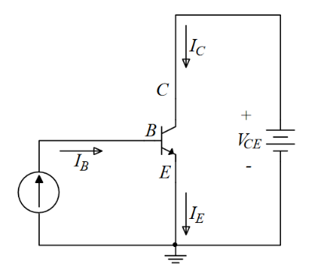

Figure 12 Characteristic curves of a bipolar transistor (left) for a transistor circuit (right).

# Voltage and Current Measurement

For voltage or current measurement multi-meter are used. If you want to measure a voltage, that drops at a component, you need to connect the multi-meter parallel to the component for which you want to measure the voltage. The multi-meter - called voltmeter when used for voltage measurement - is indicated by a small circle with a V for voltage.

Figure 13 Voltage measurement

As indicated in Figure 12 right side, a small current has to flow over the voltmeter to enable the measurement of the voltage. Therefore, the voltmeter influences the circuit, i.e. in the figure it influences IR1 and by that the voltage which drops at R1. The inner resistor of the Voltmeter has to be large compared to the component for which you measure the voltage (R1 in the figure) that the current Im over the voltmeter is small. When Ri is very large, we can assume Im=0 and we have an ideal voltage measurement (we call the voltage measurement unloaded when we can neglect the current which flows over the voltmeter).

To measure the current that flows through a component in a branch with a multi-meter you need to connect it in series with the component. When we measure the current, we call the multi-meter amperemeter. The inner resistance of the ampere- meter needs to be very small otherwise the circuit behavior is changed and not the correct current is measured.

Figure 14 Current measurement

# Initial Questions

**Day one:**

1) How to connect a multi-meter to the component for which you want to measure the voltage?

2) How to connect a multi-meter in the branch for which you want to measure the current?

3) Measurement error

1. Calculate the voltage at the resistor R1 (Figure 12). The voltage source shall deliver 12V and R1=100Ω, R2=500Ω, R3=200Ω and R4=100Ω.
2. Calculate the voltage which is measured at R1 when a voltmeter with Ri=1kΩ is used for the measurement
3. What is the reason for the measurement error?

4) What is a linear component?

5) Are LEDs linear components?

6) Describe the main function of the characteristic curve of a diode.

7) Function of D1: What is the function of D1 in your circuit?

8) Why it is important not to exchange the contacts of an electrolyte capacitor?

9) Is a z-diode used in forward or reverse direction. Do you connect n- or p doped region of the diode to the positive voltage?

10) Why is a bipolar transistor is not symmetric? What happens when you connect it in the wrong direction?

**Day 2**

1. How can you measure the current in a branch when you are not able to connect an amperemeter without de-soldering contacts of components? Take as an example the measurement in the branch over the red LED.

.

1. Measurement of the characteristic curve of an LED: In the description of the measurement, you don’t scan in equidistant steps the forward voltage and measure the forward current. Instead, you are requested to measure the LED current sufficiently often per current decade (chosen value in the experiment is 5 times per decade) because you want to have a nice plot of the characteristic curve. Why you have to do that?
2. How do you determine the exponent of an exponential curve out of a logarithmic plot, i.e. usually you plot the current on a logarithmic scale (natural logarithm) and the voltage you plot on a linear scale?
3. How does the forward voltage of an LED at a given forward current depends on the wavelength of a LED. What is the reason for this dependency?
4. Consider a bipolar transistor. What is the magnitude of IC when IB=0?
5. How can you measure the amplification factor of a bipolar transistor?
6. How can you measure the current IB for T1 without modifying the circuit.

.

1. What voltage drops between base and emitter when the transistor is switched on and a significant current IC flows.

# Experiments

## Connect the board to the power supply and test the functioning of the device.

.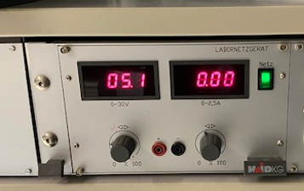

Figure 15 Power supply

With the rotary knob you limit the voltage or the current. When you move both to the left side you get the maximum voltage and current. You keep first both at the left side (volage 0V, current limitation 0A).

You attach the voltage and ground cable to the terminal clamp. Take care for polarity.

You turn the current limiter slightly as depicted on the image (you want to limit the current roughly to 20mA to avoid that a too large current will flow if there is a failure in your circuit). Now you increase slowly the voltage by turning the voltage regulator. What do you observe? When do the LEDs light on?

## LED characteristic curve measurement

Measure the characteristic curve of the red LED, i.e. the current which flows over the LED and the voltage that drops at the LED. For that you determine first the precise resistance of R6 using the function to measure the resistance of a component with a multi-meter (you have already done it). Due to the fact, that the red LED and R6 are in one branch you can use Ohms law to measure the current over the LED by the voltage which drops at R6. You have to measure the current from the μA to the 5 mA range. Take 5 measurements per decade (example for the decade from 1µA to 10µA: 1µA, 2µA, 3µA, 5µA, 8µA). The precise values are not important, but that there are sufficient measurements distributed in the respective current decade), For 1 µA you need to set the voltage of the power supply roughly to 2,2 V. The maximum current is limited, roughly 6mA, by the function of the circuit.



Plot the characteristic curve fully linear, i.e. I versus V.

Plot the characteristic curve using the logarithmic scale for the current, i.e. ln(I) versus V.

Do you observe what is theoretically expected? Determine the emission (also called ideality factor) factor of the LED diode.

## LED voltage measurement

Measure the voltage at the source and at the LEDs (red, yellow, green) when the LEDs emit maximum light (maximum current), i.e. just before next LED is switched on for red and yellow LED and at 20V source voltage for green LED. Choose the resistor R5 for current measurement for yellow and green LED (R6 for RED LED as before).



Do you observe the expected dependency of the forward voltage from the frequency of the light.

## Understanding of the function of the Zener diodes and of the bipolar transistors

To understand the function of the circuit we use the light on of the green LED. Step the source voltage in from 4V to 14V (values see table) and measure the voltage at ZD1, R1, R2 and R5. and determine the current over ZD1.

|  |  |  |  |  |  |  |  |  |  |
| --- | --- | --- | --- | --- | --- | --- | --- | --- | --- |
| Vsource [V] | VZ1 [V] | VR1 [V] | IR1 [mA] | VR2[V] | IR2 [mA] | VR5[V] | IR5 [mA] | I BE T1 | B |
| 4 |  |  |  |  |  |  |  |  |  |
| 7 |  |  |  |  |  |  |  |  |  |
| 10 |  |  |  |  |  |  |  |  |  |
| 10,5 |  |  |  |  |  |  |  |  |  |
| 10,9 |  |  |  |  |  |  |  |  |  |
| 11 |  |  |  |  |  |  |  |  |  |
| 11,1 |  |  |  |  |  |  |  |  |  |
| 11,3 |  |  |  |  |  |  |  |  |  |
| 11,4 |  |  |  |  |  |  |  |  |  |
| 11,5 |  |  |  |  |  |  |  |  |  |
| 11,6 |  |  |  |  |  |  |  |  |  |
| 11,8 |  |  |  |  |  |  |  |  |  |
| 12 |  |  |  |  |  |  |  |  |  |
| 12,2 |  |  |  |  |  |  |  |  |  |
| 12,4 |  |  |  |  |  |  |  |  |  |
| 12,6 |  |  |  |  |  |  |  |  |  |
| 12,8 |  |  |  |  |  |  |  |  |  |
| 13 |  |  |  |  |  |  |  |  |  |
| 13,2 |  |  |  |  |  |  |  |  |  |
| 13,6 |  |  |  |  |  |  |  |  |  |
| 14 |  |  |  |  |  |  |  |  |  |

Calculate the current which flows over the base-emitter diode of T1 IBET1 and write it into the table. You need to have precise resistor measurements for R1 and R2! If you get not reasonable values for IB of T1 explain the problem. Calculate the amplification factor B for the transistor for those cases where only the green LED is on.

Why doesn’t the green LED light on when the voltage is below roughly 11V?

At which voltage at R2 the green LED lights on?

What happens with the transistor T1 when the green LED lights on?

What is the maximum voltage you measure at R2? What is the reason for it?

## Voltage measurement when green and yellow LED are emitting simultaneously light

Set the source voltage so that the green and yellow LED both emit light. Consider the loop over green LED, yellow LED and T1, D2 and T2. Which condition need to be fulfilled? Measure the five voltages and check it.

# Function

Describe the function of the circuit, i.e. why the LEDs light on and off in the respective order when the source voltage increases, in especially:

Why first only lights on the red LED?

Why gets the red LED brighter and brighter when the voltage increases?

Why the yellow LED lights on?

Why the red LED stops lighting when the yellow LED lights on?

Why the green LED lights on?

Why the yellow LED stops lighting when the green LED lights on?

Why green and yellow LED both light on within a very small voltage range?

Why red and yellow LED both light on in a very small voltage range?

# Function Solution

The battery voltage is connected via the reverse polarity protection diode D1.

1) Display of the lowest voltage range (red):

Via the resistor R5, the transistor T3 is controlled. As soon as the input voltage is the sum of the light-emitting diode voltage of LED3 (approx. 1.6V) plus the breakdown voltage of D1 and D3 (approx. 2 x 0.6 V) and its Basis-Emitter voltage (approx. 0.6V) reached, i.e. at around 3.5 V, current will flow through the branch with the LED3. From this voltage (3,5V), a weak glow of LED 3 is observed that towards higher input voltages is getting stronger and stronger, i.e. a larger current flows.

2) Display of the middle voltage range (yellow):

When the input voltage becomes so high that it exceeds the breakdown voltage of D1 and that of the Zener diode ZD2 and can each drop an additional 0.6 V at the resistors R3 and R4, then transistor T2 switches and lights up LED2. However, when transistor T2 is switched through the voltage at the base of T3 is pulled down to approx. 2.3V, i.e. 1.7 V of LED2 plus 0.6 V of D2. This is no longer sufficient to control switch on T3, i.e. lower than the voltage LED1 (1,6V) plus the voltage D3 (0,6V) plus the Base-Emitter Voltage (0,6V) of T3.

3) Display of the high voltage range (green):

At the end of this chain is the transistor T1 when 0.6V drops at R2, i.e. the necessary breakdown voltage at the Zenerdiode ZD1 plus 0.6 V. is reached and a current flows through R2 plus 0,6V and due to the current 0.6V drops at only at the highest input voltage and brings LED1 to light. The voltage which drips at LED1 (1,8V) is lower than the voltage of LED2 (1,7V) plus D2 (0,6)., i.e. the current flows over LED1.This means that when LED1 lights on, LED2 and LED3 for the middle and lower voltage range are off.

In the transition range between two display areas, the two corresponding LEDs always light up together in a small voltage range. This is due to circuit technology and no failure.